..0
WS – 401: INTRODUCTION TO WEED SCIENCE

Course Objectives
Upon completion of this course:
- Students will learn to identify different weeds.
- Students will become aware of the reasons weeds must be controlled, and the problems that arise if they are not.
- Students will learn why studying weed science is important
- Students will learn about the weed control methods and the positive and negative aspects of each.
- Students will learn the common chemical and trade names of commonly used herbicides.
- Students will learn how to properly select and apply herbicides.
- Students will learn the factors that affect herbicide performance.
- Students will be able to design and implement a weed control program for various crops.
Facts about Pakistan
There are more than 200 countries in the world. Among these there is a country that is 10th times smaller than Russia and its Canal system is 3 times bigger than Russia. This country ranks 2 in term of peas production, 4th in term of apricot, cotton and sugarcane production, 5th in term of onion and milk production, 6th in term of dates, 7th in term of mangoes, 8th in term of rice production, 9th in term of wheat production and 10th in term of oranges production. It ranks 25th in term of agricultural production in the world. The wheat production in this country is greater than the total wheat production in Africa continent and equal to production of south America. It ranks 55th in term of industries. 4th in term of coal mines in the world and 7th in term of silver production. 1st in CNG use in the world. Gas reservoirs ranks 6th in Asia and is 7th nuclear state.

"There is nothing either good or bad, but thinking makes it so." Shakespeare
Visit: http://www.pfaf.org/index.php
Whether you live on the farm or in the city, weeds either directly or indirectly influence your everyday life. Weeds reduce yields, quality, and interfere with human efforts. These reductions are eventually passed to the consumer, either in increased prices or in poor quality products. Weeds interfere with recreational activities in aquatic areas or in parks and play ground areas. Weeds, such as Parthenium and Dandelion, cause misery to many people and result in allergy, thus causing discomfort and increased medical expenses.
Weed: Weeds are familiar plants of our environment which are seen, infesting agricultural crops, orchards, vegetables, lawns, roadsides, ditches, ponds, gardens, rangelands and forests. Weed can be defined as;
- Weeds are unwanted plants and undesirable plants which interfere with the utilization of land and water resources and thus adversely affect human welfare.
- Any plant growing where it is not wanted.
- Weeds are the plants which divert the direction of human efforts.
- Weeds are the plant whose harms outweigh their benefit.
- Weeds are the plants whose virtues have not been discovered so far.
Weed Science: Weed Science is the branch of agriculture which deals with the biology, ecology and management of unwanted plants. Currently, weed science, like the entire field of agricultural science, is going through a new era of technological change. Weed scientist are facing newer challenges, particularly in the light of emergence of weeds resistant to herbicides, shifts in weed flora and concerns about herbicides residues in food, soil, ground water and atmosphere.

Factors influencing crop production can be divided into three groups. Firstly, yield-defining factors such as radiation; secondly, yield-limiting factors which include soil moisture, nutrient availability and length of growing season and thirdly, yield-reducing factors which encompass disease, insects and weeds.

Advantages of weeds (for more information visit : http://www.pfaf.org/index.php)
- Some weeds have medicinal value 2. Aesthetic value
3. Fodder for animals 4. Reduce wind and water erosion.
5. Used as green vegetables 6. Used as fuel
7. Can be used as allelochemicals for suppressing other weeds 8. Pollution abatement

Disadvantages of weeds
Reduction in crop yields due to weeds result from their multifarious ways of interfering with crop growth and crop culture. Weeds compete with crops for one or more plant growth factors such as mineral nutrients, water, solar energy, space and they hinder crop cultivation operations.
- Competition for mineral nutrients: Being hardy and vigorous in growth habit; they soon outgrow the crops and consume large amount of water and nutrients. Thus causing heavy losses in yields. An average weeds growing in crop field during the kharif season remove 46.6 kg ha⁻¹ N, 12.1 kg ha⁻¹ P and 73.3 kg ha⁻¹ K. In general, weeds remove N and K from soil in much greater quantity than P. In some cases weeds consume more NPK as compared to crops plants.
- Competition for water: For producing equal amount of dry matter, the weeds, in general transpire more water than most crop plants. It is reported that wild mustard transpires about four times more water than a crop of oat.
- Competition for Solar Energy: About 99% of dry matter in plants is made up of organic matter that is dependent on solar energy. When plants are mutually shaded, their production potential is greatly reduced even though water and other nutrients are available to them in abundance.
- Competition for space: Weeds compete for space both in the rhizosphere and atmosphere. In the presence of weeds, crop plants also have limited space to develop their shoots, which is responsible to reduce photosynthesis in them.
- Weeds reduce the crop quality: Weeds may reduce the quality of the crop produce in many ways. Weed seed like wild mustard, sweet clover, a Mexican poppy, bulblets of wild garlic and wild onion when threshed and ground with winter grains can results in serious consequences besides imparting objectionable odour to the flour. Khanna observed that Striga (Striga Spp.) reduced the quality of sugarcane juice by 3.9 to 8.9 percent.
- Weeds impair the quality of the animal produce: Many weeds in pastures and forage crops impart undesirable flavors to milk and meat of animals. For e.g. Piazi, Cannabis sativa etc. imparts undesirable flavors to milk. Xanthium strumarium get attached to the body of sheep and seriously damage the quality of wool.
- Weeds harm animal health: Several weeds of grasslands and forage crops contain high alkaloids, tanins, oxalates, gulcosides, and other substances that prove poisonous to animals when ingested e.g. Silybum marianum contain nitrate which is dangerous for animals. Several cases of livestock death have been reported from Mardan.
- Weeds harbor insect pests or diseases; Weeds either give shelter to various insect pests and diseases or serve as alternate host. For example, Weed around paddy bunds harbor the gallfly.
- Weeds damage human health: Health, comfort and work efficiency of man are also affected by weeds directly or indirectly. For example, people in Islamabad and other cities are plagued year after year with hay fever and asthma aggravated by pollens of Parthenium and Dandelion.

Weeds contaminate water bodies: Aquatic weeds change the flavor, appearance and taste of drinking water. Aquatic weeds are a menace to fisheries too. Aquatic weeds on decomposition give offensive odours and pollute atmosphere.
- Weeds cause quicker wear and tear to farm implements: Being hardy and deep-rooted, the tillage implements get worn early.
- Weeds reduce the value of the land: Agricultural lands heavily infested with perennial weeds like Imperata sp., and other weeds, always fetch less price.
- Less efficient use of land: In case of perennial weeds, the carrying capacity of the grazing lands is reduced and cause depreciation of land value.
- Increase in cost of cultivation: In fields of crops infested with weeds, the tillage operations require high cost.
- Disturbance in Public places: it is desirable that public places be kept clean of weeds. Presence of weeds around our living and working places makes the surroundings dull.
- Weeds on roadsides may create security problem.
- Weeds clog irrigation and drainage schemes, and hinder or prevent navigation. Rural fishing communities can be seriously affected. Hydroelectric facilities can become clogged and forced to shut down. In some cases fishing and transport become impossible. Floating weeds also create a favorable environment for the breeding of the vectors of insect-borne disease.

Estimated crop losses (%) due to weeds in Major crops of KPK
(For more information visit: www.wssp.org.pk)

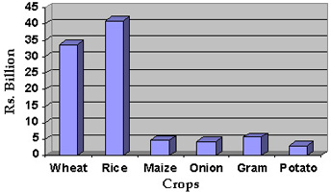
Why we classify weeds?
The significance of classifying weeds into these groups is that their physical structure and biochemical reactions are different enough that herbicides have been developed that can selectively control one group without injuring the others. The herbicide Bromoxnal can be applied over the top of turf grasses to control dandelion, without hurting the turf grasses, while Clodinapop can be applied over the top of annual flowers to control grasses growing around them. Without knowing and understanding the differences between weeds, you cannot develop effective and efficient weed control programs.
CLASSIFICATION OF WEEDS ACCORDING TO GROWTH DURATION
Based on life span, weeds are classified into three broad groups;
Annuals complete their life cycle in one growing season/year. They propagate by seeds. Normally they are considered easy to control but they are very persistent because of abundance of seeds production which continues to germinate until conditions become unfavorable.
There are two types of annuals: Summer annuals and Winter annuals.
The summer annuals start germinating in the spring or summer, attain most of their growth during summer and usually mature and ripen seeds in summer or autumn. e.g. Portulaca oleracea.
Winter annuals germinate in autumn or winter, produce flowers and ripen seeds in the spring or early summer e.g. wild oat (Avena fatua), Ammi-visnaga.

Biennials have a life span of two years. They germinate in the spring or summer. The first year’s may be purely vegetative and this is known as rosette stage. The tap root is often fleshy and serves as a food storage organ. During the spring of the second year, a flower stalk arises from the crown, this is known as the bolting stage e.g. Wild carrot. The biennials are controlled like annuals by destroying the vegetative growth in the first year.
Perennials live for more than two years and some of them almost indefinitely. They propagate by seeds and under ground storage organs like rhizomes, stolons, bulbs, tubers etc. Some of them strike roots when the nodes come into contact with the soil. Perennials are very aggressive and competitive weeds.
On the basis of vegetative reproduction, perennials are classified into simple perennials, and creeping perennials.
Simple perennials reproduce mostly by seeds e.g. Dandelion. Vegetative reproduction occurs when roots and stems are cut mechanically.
Creeping perennials spread by stolons (Runners) (above ground part) e.g. Cynodon dactylon (Bermuda grass), rhizomes (underground part) e.g. Sorghum helepensis (Johnson grass)
This behavior is not always constant, however, as the duration of weeds is sometimes determined by climatic factors. Many weeds that are annuals or biennials in severe climates may act as biennials or perennials respectively in milder climates or mild winters. Most weeds belong to the group of perennials, followed by annuals. Biennials comprise only a small percentage of weeds.

Useful Classification of weeds
On the basis of leaf morphology, weeds are classified as
(a) Broadleaf (b) Grasses (c) Sedges
- Broad leaf Weeds: Broadleaf weeds are a highly variable group of plants, but most have showy flowers and net-like veins in their leaves. They are easy to separate from grasses due to their generally different leaf structure and habits of growth. Some examples of broad leaf weeds are Chenopodium album, Convolvulus arvensis, Euphorbia helioscopia and Silybum marianum.
- Grassy weeds: True grasses have hollow, rounded stems and nodes (joints) that are closed and hard. The leaf blades are alternate on each side of the stem, have parallel veins, and are much longer than they are wide. Some examples are Phalaris minor, Poa annua and Avena fatua. These weeds belong to family Poaceae/Gramineae.
- Sedges: Sedges are an important group of "grass-like" weeds; however, they are not true grasses and are characterized by a solid, triangular-shaped stem with leaves extending in three directions. There are annual sedges (some are often called water grass), and the predominant and difficult to control perennial sedges. Of the latter group, yellow nut sedge is yellow-green in color and reproduces by seed, rhizomes (underground stems), and tubers. The rhizomes radiate from the plant, with a single bulb or tuber at the end, which may produce a new plant. Those weeds which have triangular stem and belong to family Cyperaceae. e.g Cyperus rotundus

Classification on the basis of habitat
- Aquatic weeds: As the name indicates, those weed which grow in or near the water are called aquatic weeds e.g. Eichhornia crassipes (Water hyacinth).
- Terrestrial Weeds: All the weeds growing in our agricultural crops, roadsides etc are grouped as terrestrial weeds. e.g. Ammi-visnaga, Silybum marianum,

INTERFERENCE
The interaction (interspecific or intraspecific) of one plant with another plant in an agro-ecosystem is termed as interference.

The three major types of interference between the plants are;

Competition
It has been derived from Latin word “Competere” which means to ask for the same things that another does. Competition in ecology involves two or more organisms seeking for a particular factor, thing or material when they are in short or limited supply.
The degree of weed competition is determined by the weed species (Fig. 1) infesting the area, density (Fig. 2) of infestation and duration (Fig. 3) of infestation.
Weed species differ among themselves in competitive ability e.g. heaviest losses in rice yield under the infestation of Echinochola crusgalli than of Monochoria. Similarly Avena fatua was found more competitive in wheat than Poa annua.
Increase in weed population has a direct effect on crop reduction. In an experiment it was found that increase in weed density of Echinochola crusgalli caused decrease in grain yield of rice.
The duration of weed infestation and the time of weed elimination have a great influence on crop growth and yield. Weeds that are not controlled within 02 or 03 weeks of emergence usually affect the yield. In most crops, weed infestation during the first 3 to 8 weeks is very critical.

Critical Period of Competition (CPC)
Weeds are not equally detrimental to crop at all times. During crop period there is a certain time when crop plants are most sensitive to competition by weeds. This time is known as the critical period of competition. Before and after this period, the damage caused by weeds is usually not significant and control measures may not be justified. In weed management, the aim should not be complete weed eradication but to shift the weed-crop competition in favour of the crop and against the weeds. In our country many farmers apply herbicides at anthesis of wheat. Thus the use of herbicide at this stage not recommended.

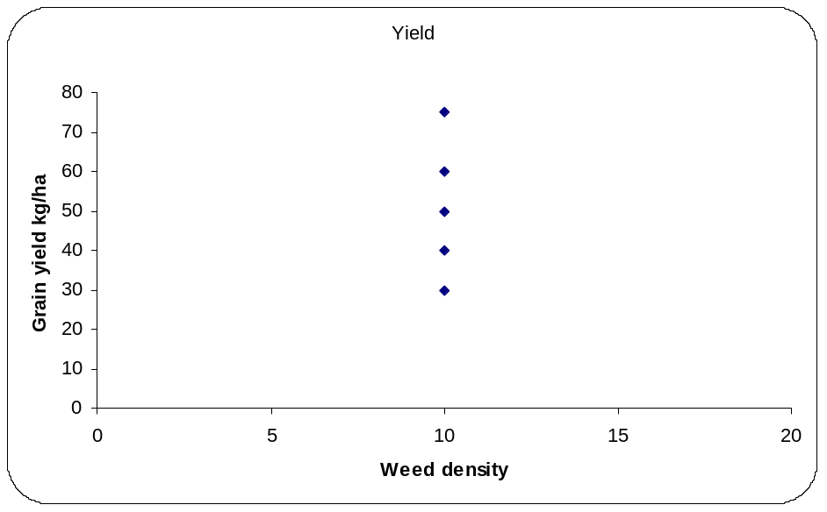
Fig. 1. The competitive ability of different weed species is different

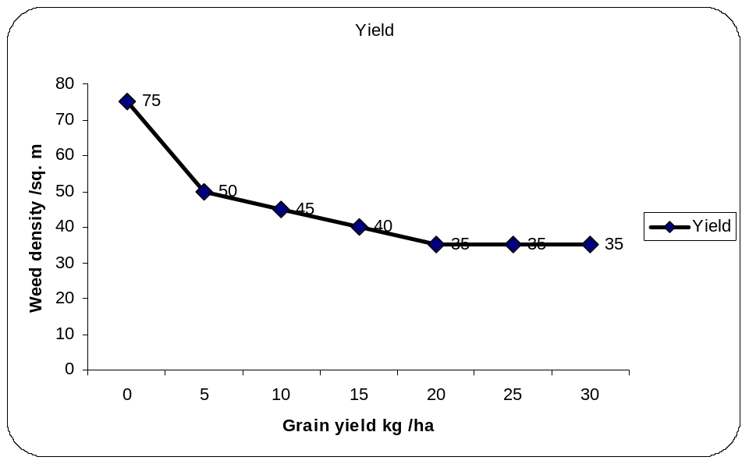
Fig. 2. With the increasing weed density, the crop yield is decreased.

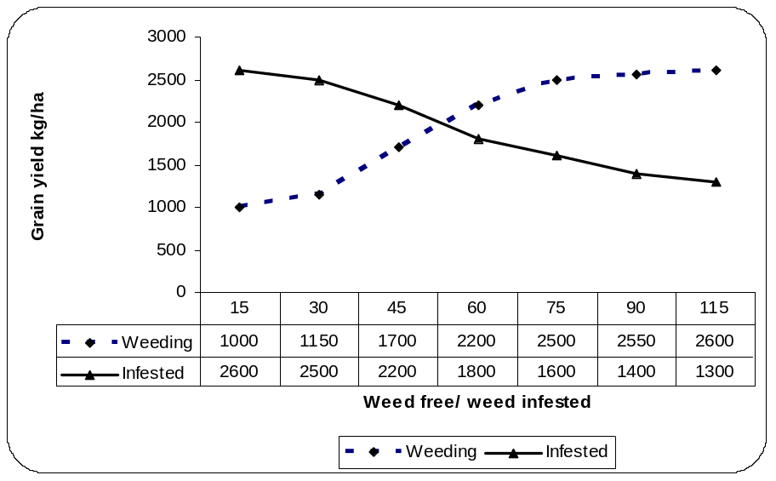

Fig. 3. Duration of weed competition

WHAT IS A TRAP CROP?
Trap crops are plants which stimulate the germination of parasitic weed seeds and which get not infected by them. In this way trap crops reduce the seed bank in the soil and cause a decrease in infestation. Dependent on the agricultural system different crops can be used as trap crops. The efficacy of a trap crop might not exceed 10% to 40% in one year, i.e. up to 10 to 40% of the Orobanche and Striga seed bank in soil might become stimulated.
Trap crops for Striga sps.
Sunflower, Castor bean, Ground nut, Soy bean, Pea, Cowpea.
What is a catch crop?
Catch crops are host plants of parasitic weeds, which induce germination and get attacked. Catch crops are harvested or ploughed under after 6-8 weeks before the parasites emerge and reproduce. In this way catch crops reduce efficiently the parasitic weed seed bank in the soil.
How to use catch crops?
Catch crops are used in "managed" fallows or as "preceding crops" for crops with a short growing period. Catch crops should not be planted like normal crops. To have a very high effectivity in reducing the seed bank, e.g. sorghum as catch crop for Striga hermonthica and S. asiatica or small-seeded Vicia spp. or lentils for Orobanche crenata have to be densly sown or planted. Overview of trap and catch crops as controls for parasitic seed plants
Catch crops | Trap crop
Mechanisms
Real host becomes parasitized and has to be destroyed!(after 6-8 weeks, latest before blooming of the parasite) | false host, stimulates only germination, without becoming parasitized
Advantages
- safe and fast method through calculated stimulation  - fodder harvest possible  - green manure  - likely to be used as preceding crop | - no additional labor when included in crop rotation  - good results with effective trap crop
Disadvantages
- costly due to additional labor  - has to be closely planted  - not usable if growing season to short  - needs good mechanization  - possibly loss of a growing period | - may not be efficient  - possibly not practicable for ecological/economical reasons  - development of the parasite in weeds needs to be eliminated

DORMANCY
The inability of seeds to germinate under favorable conditions is called seed dormancy. It is the arrested development and reversible rest period of plant organs, either of a seed or of any vegetative part. Dormancy is not an absolute block to germination but an adaptation to evade unfavorable environmental conditions for a period of time. Failure or delaying of germination of a fully mature and viable seed of a species under conditions of moisture, temperature, light and oxygen supply which are normally favorable for the later stages of germination and growth of the species, is seed dormancy.
Types of Dormancy
There are three types of dormancy. Harper says “some seeds are born dormant (innate), some achieve dormancy (induced) and some have dormancy thrust upon them (enforced).
- Innate or Primary Dormancy. Some seeds that are born dormant show this type of dormancy when they are attached to the parent plant. This is considered as inherent property to the mature seed as it leaves the parent plant. Such dormancy may be due to immature embryo, impermeable seed coat, inhibitor – promoter interaction or chilling requirement (exposure to cold).
- Induced or Secondary Dormancy. Some seeds may achieve dormancy due to the interaction of the seed with the environment for example, with warm, dry conditions. It develops when a non-dormant seed is exposed to certain conditions and the dormancy continues after the seed is removed from those conditions.
- Enforced or Environmental Dormancy. Some seeds have dormancy thrust upon them due to conditions of deficient oxygen, excess carbon dioxide, cold temperature etc. induced by man or in nature. In such dormancy, limitations of the environment or habitat prevent non-dormant viable seeds from germinating and germination occurs as soon as seeds are freed from the limiting conditions. Weed seeds buried deep in the soil are put under enforced dormancy and bringing seeds to the surface with a favourable environment may terminate enforced dormancy.

Importance of Dormancy
In seed bearing plants the dormant seeds are much more resistant to unfavourable conditions than the mother plant and act as a solution to the periodic as well as non-periodic changes in the environment.
In temperate zones, dormancy is a survival mechanism that prevents the fall germination of species that are not winter hardy in tropical zones, many weed seeds have no dormancy and germinate soon after falling to the ground. Dormant seeds possess the highest potential for resum
ing growth and forming fresh individuals and are nature’s general insurance for survival (perpetuation) of the species. In some field crops where the economic yield is that of the seed itself, dormancy helps man to harvest, process, store and use as seed for future crop and/or as food, feed, oil seed etc. a limited dormancy in crop seeds or kernels or seed like structures is a useful attribute that prevents sprouting, when the mature crop or mature part of the crop gets wet due to rain or flood or when harvesting operations are delayed by wet weather.
Seed Dissemination
Dispersal means scattering or dissemination. Seed dispersal is the dissemination of propagules (seed or vegetative parts). Theoretically, if it is to be successful, dispersal should place a seed in a location that allows a greater likelihood of survival than its location with the parent plant. Weed seeds can be dispersed in space and through time. Dispersal in space involves the physical movement of seeds from one place to another. Weed seeds are dispersed by natural and artificial means. The natural means of seed dispersal include wind, water, animals and the forceful dehiscence (rupturing) of seed pods or capsules. The artificial means of seed dispersal are largely associated with the movement of man and his agricultural material from place to place and with his cultural practices of arable lands.
Methods of seed dispersal in space
- Wind. Seeds dispersed by wind can have several distinct forms. Some weed seeds such as seeds of witch weed (Striga lutea) are so tiny and light that they are readily wind-borned and carried from one place to another. Some seeds have special appendages such as parachutes, wings and tufts of hairs. Some weed seed are easily dispersed due to their feathery pappus that serves as parachute e.g, dandelion and annual sow thistle. Some weed seeds are spread by the tumbling action of dead, mature plant about the landscape as the plant is uprooted or broken off and blown about by the wind. Such plants are often referred to as “tumbleweeds” e.g, Carthamus oxycantha. Light breeze may transport small and light seeds for some distance.
- Water. Flowing water is capable of transporting almost any type of seeds, depending on the volume and swiftness of water. Weed seeds introduce into flowing water by heavy rains and by wind but the most common means is by the seed dropping into the water from mature plants growing along the water channels. e.g, Plantago lanceolata, Rumex crispus. Some weed seeds have corky structure or air-filled or pods and hence they are easily dispersed by water due to its light weight. e.g, Rumex crispus.

- Animals. Animals also disperse the weed seeds due to fact that some seeds having barbs, bristles, hooks and hairs which catch in the animals’ fur or hair, or seeds which have sticky seed coats which adhere to passing animals. Seeds having hooks or bristles included e.g. Xanthium sps. Some seeds have sharp projection that is embedded in the feet of animals, soft soles of shoes of man or tyres of machinery (e.g. Tribulus sp.). Seeds with sticky seed coats include plantains (Plantago sp.). Animals and birds also carry viable seed from one place to another in their digestive tracts and are excreted in distant areas. Insects also carry small seeds short distances.

Artificial Dissemination
Man distributes weed seeds by means of his transport system and by farm machinery, especially harvesting equipment, moving from field to field. However, the principal means by which man introduces weeds into his crop lands is by planting crop seed contaminated with weed seeds. Weed seeds and vegetative reproductive parts of perennial weeds may be carried in the mud or soil adhering to the wheels or bodies of farm equipments. Introduction of ornamental plants may also cause the spread of vegetative parts of weeds, hidden in the pots.

Spread of Perennial Weeds
Perennial weeds spread by either seeds or asexual means or both. The dragging of vegetative parts like roots, rhizomes, tubers etc. by tillage equipment is a common means by which perennial weeds are spread over a field. The transport of these vegetative parts of weeds is a common means by which perennial weeds are spread from one locality to another. Roots of a single plant of field bindweed spread laterally about 2.5 feet and penetrate to a soil depth of about 4 feet during the first season of growth. By the end of the third season of growth, a single plant of field bind weed is capable of spreading throughout an area of about 18 feet in diameter and penetrating to a depth of 18 to 20 feet.

METHODS OF WEED CONTROL

~Know your weeds to control your weeds

~Identify your weeds to rectify your weeds

~Understand your weeds to withstand your weeds

~Any plant can become a weed

~No plant is born a weed (Nature makes plants - Humans make weeds)

All weed control techniques can be grouped into five general categories listed as follow;
1. Preventive weed control: Preventive weed control is to prevent the introduction, establishment and spread of specified weed species in areas not currently infested with these plant species. These areas may be national, state or local. At national and state level it is primarily practiced through laws and their enforcement, such as federal or state seed law or weed law. In this method, farmers and people are the key to preventive weed control.
It is easier to prevent the introduction or germination of weeds than to control them after they are already established. Seven possible methods of preventive weed control exist:

  - Use “clean” seeds that have no weed seeds in them.
  - Keep the rice seedling nursery free of weeds and make sure weeds are not transplanted with seedlings.
  - Keep bunds and irrigation canals free of weeds.
  - Keep tools and machinery clean so that seeds are not transported from field to field.
  - Keep livestock out of rice fields.
  - Prevent weeds in the area from producing seeds.
  - Prevent entry of water-carried vegetative propagules of weeds that are perennial.
Preventive control involves all measures taken to forestall the introduction and spread of weeds. Although preventive measures will reduce infestations, no program can eliminate the wide variety of weed species on a given piece of land. Success of a preventive program varies with the weed species and the amount and constancy of effort that you devote to prevention.
Use weed free seed
Any weedy plant in a seed field poses the risk that some weed seeds will find their way into the crop-seed supply even with the best cleaning techniques. However, the more effective the cleaning technique, the less potential for infestation. A 1986-1989 weed survey in Alberta identified the sources of seed used by the average producer.
The greatest potential source of weed seeds comes from seed that is not inspected. The sources of these seeds are "home grown" and "other farmers". Alberta has a good record of sanitation because 98% of this seed was subsequently cleaned at a seed cleaning plant (64%) a private commercial plant (15%), on farm (6%), or in the local elevator (6%). With the exception of the "on-farm" and the elevator system, which are primarily designed for dockage removal, the available cleaning systems remove the majority of weed seeds. Pedigreed seed, while not weed free, comes with a certificate of analysis that identifies the species and number of weed seeds found in a seed sample. Seed dealers must supply a certificate to buyers upon request. An example of the seed standards is shown in the next table. The higher the grade, the fewer weed seeds allowed.
Maximum number of weed seeds for 500 grams of crop seed:
Quality | Total Weed Seeds | Total Other Crops
Canada Registered #1 | 3 | 2
Canada Registered #2 | 6 | 4
Canada Certified #1 | 3 | 4
Canada Certified #2 | 6 | 10
Canada Common #1 | 10 | 25
Canada Common #2 | 20 | 50
These standards apply to barley, buckwheat, lentils, lupine, rye, sainfoin, etc. With minor variations, they also apply to wheat, canola, flax, and oats.
Prevent Weed Seed Formation
A weed can produce a few hundred to several thousand seeds depending on the species and the growing conditions. These seeds add to the soil seed bank and will cause problems for producers. The following table outlines the number of weed seeds that can be prevented from entering the soil through timely removal of weeds.
Seed production capacities of selected weeds:
Common name | Approximate number of seeds per plant
Barnyard grass | 7,200
Chickweed, common | 12,000
Buckwheat, wild | 1,200
Chamomile, scentless | 200,000+
Foxtail, green | 34,000
Kochia | 14,600
Lamb's-quarters | 72,000
Medic, black | 2,300
Mustard, wild | 2,000 -3,500
Oats, wild | 250
Pigweed, broadleaf | 117,000
Plantain, broadleaf | 36,000
Purslane | 52,000
Shepherd's-purse | 38,500
Smartweeds | 3,000
Sow thistle | 10,000
Spurge, leafy | 250
Thistle, Canada | 700
Stevens, O. A. 1932. American J. Botany 19:784-794.
Prevention of seed production is an important control strategy. Mowing some weeds is an effective control; however, other weeds with different growth habits are only slightly affected by mowing and simply continue to flower and produce seeds below the height of the mower. Tillage of fallow fields must be conducted before seed production. Extremely weedy crops can be cut for forage before the weeds go to seed. If viable seeds exist, the feed should be put up for silage because seed viability is usually destroyed in the ensiling process.
Practice Fence Line and Headland Control
Fence lines and headlands serve as habitat for beneficial insects and wildlife. Disturbing these sites may not be necessary as long as they do not act as a refuge for weeds or insect pests. If fence lines, headlands and roadsides are sources of infestation, try planting them with native plants and grasses that are adapted to our climate and growing conditions, and thus are competitive with weeds. Mowing or grazing uncultivated wastelands helps to control weeds. If possible, delay mowing or intensive grazing until late July, to allow ground nesting birds to raise their broods.
Prevent Spread with Soil and Equipment
Weed seeds and vegetative parts of plants move with farm equipment and soil. Long distance transport is responsible for the introduction of new weeds to previously clean areas. Industrial equipment, seed and used farm machinery are the worst offenders. Equipment should be cleaned before moving from one area to another. Place a tarp over grain and soil when it is transported. In addition to preventing weed spread, tarps reduce unnecessary loss of a valuable product.
The next table shows the net loss of grain and associated weed seeds after a three-ton truck travelled 10 km at 80 km/hour.
Loss of grains while in transport
Method of box cover | Crop | Net loss lb | Bushels
Full tarp | Barley | 0 | 0
Level box with baffle | Barley | 95 | 2.0
Level box only | Barley | 825 | 17.2
Level box with baffle | Oats | 95 | 3.0
Level box only | Oats | 745 | 23.2
Level box with baffle | Canola | 160 | 3.2
Level box only | Canola | 1,125 | 22.5
Prevent Spread through Feed and Manure
Weed seeds may remain viable after passing through animals, resulting in contaminated manure. Screenings used for feed should be finely ground, cooked or pelleted to ensure destruction of all the weed seeds. Poultry are most effective in destroying weed seeds as their crops grind the seeds. In order of decreasing effectiveness are sheep, horses, swine, and cattle.
Once in manure, however, the rate of breakdown depends on the type of weed seed and the temperature of the manure. If the manure is frozen or cold, the seed will live longer.
Handling New Weeds in Your Fields
- Have the weed identified by a professional.
- Prevent seed production by removing the plant and seed head. Bag and bury viable seed or destroy the seed through incineration.
- If the plant is a perennial, destroy the root system by physical, chemical or mechanical means. Use cutting (discs) rather than tearing (cultivator) equipment on perennial weeds to prevent root spread to areas that are not infested.
- Check infestation sites before harvest to insure no more seed has set.
- Monitor sites for three to four years to avoid re-infestation from vegetative parts or seed that did not germinate in the first year.
Weed free crop seed: Planting crop seed contaminated with weed seeds is one of the most common ways of introducing weeds into croplands. Plant only those crop seeds that have been cleaned to remove as many weed seeds as possible.

2. Cultural weed control
Cultural weed control is the practice common to good land and water management. Similarly the use of fertilizer, selection of variety, method of sowing, seed rate of crop, time of sowing can reduce the weeds infestation if well planned.
Smother crops: Smother crops are those crops that are especially highly competitive with the weed species infesting an area for light, nutrients and moisture. Crop plants used for this purpose include alfalfa, clovers etc. any highly competitive crop that is well adapted to an area may be suitable for use as a smother crop.

Crop rotation: When same cultural practices are followed year after year on the same land, crop associated weeds tend to multiply rapidly and successfully, compete with the crop plants, reducing yields, quality and economic return. Thos weeds which have close resemblance with the crop, cause more damage to the crop, because the weeds will have the same biology as have the crop and thus the same resources will be used by the crop and the weeds. E.g. Avena fatua (wild oat) is more competitive with the wheat plant as compared to Anagallis arvensis.

========
Rice is presently grown in 113 countries. Rice farming also offers a suitable environment for the culture of fish and other aquatic organism. This publication synthesizes the available information on the role that aquaculture can play in rice-based farming systems towards food security and poverty alleviation. The real impacts of rice-fish farming and its future potential in terms of improved income and nutrition are significant but generally underestimated and undervalued. Notable changes have taken place in pest management in rice farming, and in fish production and availability making this a particularly relevant moment for emphasizing the importance of rice-fish farming. There is considerable potential for rice-fish farming to expand further in many countries and to contribute substantially towards global food and nutritional security.

- Mechanical (Physical) Weed Control
Mechanical weed control is the use of physical force to control weeds. Mechanical weed control involves hand pulling, hoeing, mowing, water management, smothering with non-living material, burning/Flaming and machine tillage.

Hand pulling: Hand pulling is an effective practice for the control of weed seedlings of annual and biennial weeds. It is not effective against established perennial weeds, as underground vegetative reproductive parts usually are not disturbed.
Hoeing: Hoeing is highly effective method against annual and biennial weeds but effective against perennials if practiced at intervals of 1 to 2 weeks during the growing season.
Mowing: Mowing has limited value as a means of weed control. It is primarily used to reduce seed production and to restrict unsightly weed growth e.g, roadsides, water channels etc.
Flooding: Flooding is effective weed control under certain conditions. Flooding is effective only when the roots/shoots of the weeds are completely covered by the water for a long period. Flooding kills weeds by depriving the plants of air, thus the plants die of suffocation. Its use is limited.
Mulching/Smothering with non-living material: This method is also effective but under certain conditions. The objective is to completely exclude light from the growing weed plants, thereby preventing photosynthesis and further growth. Materials used for this purpose include hay, manure, straw, rice hulls, paper and plastic film.

Burning: This method has been practiced for many years as a means of general weed control in non-cropped areas such as rail road, irrigation canals, drainage ditches and road sides. This method is applied in dates and some times in sugarcane.
Flaming: Selective flaming operates on the general principle that the crop plants are tall enough at the time of flaming, directed towards the ground near the base of the plants. The flaming apparatus is generally tractor-mounted and consists of a fuel tank, pipelines, pressure regulator and burners. The fuel is either butane or propane, stored under pressure. The theory behind flaming is that the heat intensity cause the rupture of cell wall but not to cause actual combustion of the plant material.
Machine tillage: Machine tillage or cultivation is and continues to be one of the principal means by which weeds are controlled. Machine tillage is similar to hoeing, except that the power for the cultivating tools is provided by animals or mechanical engines, rather than people.
4. Chemical weed control: Chemical weed management is the control of weed through application of herbicides. “Any chemical which kill or greatly retard the plant growth and development is called herbicide”.
On the basis of mode of action, herbicides can be classified into two i.e.
  - Systemic or translocated herbicides: These are those herbicides which move in the plant body from one part to another part. i.e. move within the plant system. E.g. 2,4-D.
  - Non-systemic or contact herbicides: These are those herbicides which kill only those parts of the plant which come into direct contact with herbicides. e.g. Paraquat.
On the basis of selectivity herbicides can be grouped into two i.e.
- Selective herbicides: Those herbicides which kill only selective plants (weed) while the crop remain safe. e.g Topik. Topik selectively kill the grassy weeds while the wheat remain safe without any significant injury.
- Non-selective herbicides: Those herbicides which kill or suppress all the vegetation that is treated. E.g. Glyphosate.

Herbicides:
Herbicides may be classified in several ways depending on where and how they are applied and their action in or on the plant. Herbicides may be either foliage applied or soil applied. They may kill by contact or may be translocated through a plant.
Herbicides may also be selective or non-selective. Some herbicides may be effective either foliage applied or soil applied. Whether a herbicide is selective or non-selective may depend on several factors, such as the crop or weed present, time of application, the method of application, and rate of application.
For example, paraquat would usually be described as a foliage applied, contact, non-selective herbicide; while atrazine would usually be described as a soil applied, translocated, selective herbicide.

Foliage Applied Herbicides
Foliage applied herbicides may be applied to the leaves, stems or shoots of plants. Herbicides hat kill only those parts of the plants which the spray touches are contact herbicides. The herbicide may be taken into the plant and moved through-out the plant, resulting in plant injury or death. These are translocated herbicides. For example, if a drop of paraquat were applied to the leaf tip of a young tomato plant then only that leaf tip would be killed; however, if a drop of 2,4-D were applied to the leaf tip of a young tomato plant then other areas of the plant would express symptoms due to translocation of the 2,4-D throughout the plant.
For foliage applied herbicides to be effective they must enter the plant and this entrance may be influenced by factors, such as the shape or orientation of the leaf, roughness of the leaf surface, pubescence (hairs) on the leaves, presence of wax, or the formulation of the herbicide. For example, it is difficult to obtain good coverage of plants with narrow upright leaves such as wild onion since the herbicide bounces or runs off, while plants with prostrate leaves such as wild mustard are much easier to cover.
The presence of pubescence on the leaf may result in a herbicide not reaching the leaf surface but remaining suspended on the hairs. In such cases, the addition of a surfactant may be useful in reducing the surface tension of the water droplet and allowing it to spread through the hairs onto the leaf surface where it may be absorbed.
On waxy leaf surfaces the formulation of the herbicide may be important. For example, the amine formulations of phenoxy herbicides are not highly soluble in wax and are not as effective on plants with waxy leaves as are ester formulations which are soluble in wax.
Contact herbicides are most effective on annual weeds but are not usually effective on perennials. Translocated herbicides may be effective on annuals or perennials.

Soil Applied Herbicides
Soil applied herbicides primarily enter plants through the root system and many factors influence the effectiveness of soil applied herbicides. Factors such as tolerance of the crop or weed to the herbicide, depth of weed and crop seed, amount of sand, silt, clay and organic matter of the soil, amount and time of rainfall, and temperature are a few factors which may influence effectiveness.
One example of herbicide tolerance is the use of atrazine in corn. When atrazine is applied to a field of corn, it may enter both the corn and the weeds; however, corn has the ability to detoxify atrazine, whereas many weed species cannot, thus result in selective weed control.
Although soil applied herbicides must be moved into the soil to be effective, the amount of movement in the soil can be used to achieve selectivity. For example, if the problem weeds are in the upper 1 inch of soil and the crop seed can be planted at a depth of 2 inches, then a herbicide which does not move rapidly in the soil, or can be incorporated to a depth of 1 inch, can be used, thus resulting in the crop seed remaining below the zone of herbicide.
Persistence of herbicides is extremely important in the duration of weed control, and also in determining what crop can be planted later in the season. The persistence of herbicides applied to the soil may be influenced by numerous factors such as microbial decomposition, chemical decomposition, adsorption, leaching, volatilization and photodecomposition.
Soil type is extremely important. Soluble herbicides applied to sandy soils may be rapidly leached out of the zone containing weed seed and into the zone of germination or roots of the crop thus resulting in poor weed control and damage to the crop. In fine textured soils or organic soils, herbicides may be so tightly adsorbed that they are not available for weed control or they may be released so slowly that they are not in a concentration great enough to kill the weeds. This lack of release may also increase the persistence of herbicides into the following crop in fine textured or organic soils.
Herbicides which specify incorporation into the soil may do so to improve the contact of the herbicide with the seed and also to minimize the loss of the herbicides by volatilization and photodecomposition. Some herbicides, if not incorporated soon after application may be lost from the soil surface.
One of the major factors influencing herbicide persistence in the soil is microorganisms. These organisms may use the organic herbicides as a source of carbon for their food supply. The specific herbicide, microorganism present, temperature, water, oxygen, and mineral nutrients are all important in the persistence of the herbicide.
Generally the fastest degradation of herbicides is achieved in warm, moist, well aerated, fertile soils at pH ranges favorable to crop growth. The greatest persistence of herbicides may be expected if the soil is cold, dry, poorly aerated, and generally unfavorable to the growth of the microorganisms.

Using Herbicides Safely and Herbicide Toxicity
Herbicide accidents affect both man and the environment. Almost all herbicide accidents have been due to carelessness and could have been prevented by reading and following the label instructions on the herbicide container. The label contains important information on safety, personal protective equipment (PPE), disposal, poisoning, and treatment. The information on the label costs the basic manufacturer from 10-18 million dollars to develop.

CHOOSING THE CORRECT HERBICIDE OR FORMULATION
Choosing the correct herbicide and formulation is the first preventative measure to avoid misapplication, leaching, off-site drift, and carryover. The label should be read carefully to ensure that the herbicide provides the weed control for the weed spectrum of interest while remaining safe on the crop. Formulations that are very water soluble are more prone to runoff or leaching. Some herbicides are very persistent and do not readily break down by photodecomposition, hydrolysis, or microbial degradation. These herbicides will list rotational crop guidelines that contain information on length of time needed before planting certain crops in order to avoid crop injury.

STORAGE AND HANDLING OF HERBICIDES
Always store herbicides in a locked building away from people, animals, feed, and food. The building should have a cement floor and good ventilation. Always store pesticides in the original container with the label. Keep all pesticides out of the reach of children.
Extreme caution should be taken when handling pesticides. Never open a container at eye level, especially wettable powders in paper bags. Use proper safety equipment in a well-ventilated area away from children and animals. The label states what safety clothing and equipment are required. Respirators are needed for highly toxic pesticides. Never eat, drink, smoke, or use smokeless tobacco when handling pesticides, and wash immediately if contact is made because some formulations can cause irritation, blisters, blindness, and death. Pant legs should be left outside of boots. Remove clothing that is contaminated after spilling.
Pesticide wastes are toxic. Always have a special place away from people and buildings for cleaning spray equipment and rinsing spray tanks. Some herbicides will not rinse out of spray tanks and measuring vessels with only water. For example, 2,4-D and dicamba residues will remain in spray tanks and cause phytotoxicity to susceptible plants later unless rinsed with suitable cleaners, like one containing ammonia.

Major Winter weeds
Wild oat (Avena fatua), Canarygrass (Phalaris minor), Field bindweed (Convolvulus arvensis), Ammi-visnaga, Rumex crassipes, Anagallis arvensis, Euphorbia helioscopia, Coronopus didymus, Vicia sp. Chenopodium album, Poa annua, Medicago denticulate, Fumaria indica, Silybum marianum, Taraxacum officinale, Sisymbrium irio,

Weed control in wheat
Some herbicides are grass killer (kill only grassy weeds), some are broadleaf killer (kill only broadleaf weeds) and some are broad-spectrum (kill grasses and broadleaf weeds).
For grassy weeds: Topik, Puma super
For broadleaf weeds: 2,4-D, Buctril-M
For broad-spectrum: Affinity

Advantages of chemical weed control
- When application of other methods is not possible then chemical weed control prove economical.
- Less labor is required for application of herbicides as hoeing or any other method requires more labor.
- In rainy season hoeing can not be practiced , thus chemical weed control is the only option.
- Roots and rhizomes of the weeds are also killed.
Disadvantages:
- Development of herbicide resistance
- Species shift can occur i.e. if grassy weeds were chemically controlled for several years then the problem of broadleaf will be created and vice versa.
- Some herbicides are very expensive.
- Knowledge and skill is required for application of herbicides.
- Non-target plants can be injured.
- Pollution of the environment

- Biological weed control:
Biological weed control involves the utilization of natural enemies for the control of certain weeds. Objective of biological weed control is not eradication but reduction and regulation of the weed population below the level of economic injury. Example of biological weed control is control of common prickly pear (Opuntia inermis) by the phytophagus insect which was introduced into Australia from Argentina. Biological weed control is not practiced in annual crops but it is generally practiced for control of specific weeds.

Integrated Weed Management (IWM)
Integrated weed control involves the use of two or more weed control techniques selected from the five general categories, i.e. preventive, biological, cultural, mechanical or physical and chemical. The combined use of more than one weed control technique is advantageous, because one technique rarely achieves complete season long control of all weeds present in a particular crop.
Weed Shift:
The change in weed species composition over time is called weed shift. E.g. if we use a grass killer herbicide in a particular area then all the grassy weeds will be disappeared while the broadleaf weeds will become a problem in that area. Similarly if we use broadleaf for several years in the same field then grassy weeds will become a problem in that area. Same is the case for annual and perennial weeds.

Herbicide Resistance:
Herbicide tolerance: Tolerance is the natural ability of plants to withstand the phytoxicity of herbicide.
Herbicide resistance: It is the acquired ability of plant to withstand the phytotoxicity of herbicide.
Most species contain many different individual genotypes. It should not be surprising that these may differ in their susceptibility to a particular herbicide. If an herbicide is applied consistently over a number of years, individuals within the species that has genetic resistance to the herbicide will survive and flourish after the demise of its sensitive siblings.
This process takes more time that the species shifts. Certain herbicide families seem to develop resistant populations rapidly, whereas other families develop resistance slowly or not at all. It seems to be a question of gene frequency i.e. the number of individuals in a given field with the altered gene for resistance.
Most scientists now believe that genes for resistance to various herbicides are already present in the population even before an herbicide is introduced. Control initially may be excellent, 99.9 % or greater but a few surviving individuals will remain. Most of the cases of herbicide resistance now being studied are examples of incomplete dominance, meaning that when homozygous resistant and susceptible individuals cross, all the offspring are resistant enough to survive another herbicide application. The resistant survivors can then proliferate at a relatively rapid pace, sometimes resulting in a field-wide infestation of the resistant weed within five or six years.
What can one do about this? Weeds are not like insects. They are anchored and they do not fly away. Methods of preventing the development of resistance are primarily extensions of common sense and they have not changed over the years.

HOW TO AVERT RESISTANCE?
- Use other methods of weed control in conjunction with herbicides. This may include cultivating row crops, flaming, delaying seeding to allow mechanical control of the first flush of weeds, drainage etc.
- Rotate crops regularly when possible. Switching from a winter crop to a spring-planted one provides an opportunity to prepare the land at a different time of the year and perhaps kill the resistant individuals. Or by shifting to another crop it may be possible to use herbicides to which the resistant weeds are susceptible.
- If crop rotation is not a good option, rotate herbicides annually. To be effective, the alternate herbicide must be of a different type than the one originally used one whose biochemical mechanism of lethal action is different.
- Resist the temptation to use higher application rates when the effectiveness of weed control starts to decline. Uncontrolled individuals in the population are genetically resistant and increasing the herbicide dosage will probably not kill them anyway. Heavier application will simply eliminate the less resistant types and perhaps injure the crop enough to reduce its competitiveness, permitting the most resistance types to flourish. Higher than normal application rates may actually increase the rate of resistance development.
- Finish the job if at all possible. Hand weeding on a 2000 ha wheat ranch is not possible. But in small fields with row crops this may be an extremely inexpensive remedy in the long term. If a new herbicide provides 99 % control the first year, the remaining 1 % might be genetically resistant and this is the proper time to eliminate them, while they are few still in number.
- Herbicides combination is generally used to increase the number of weed species controlled. Such a combination will slow the development of resistance only in weeds that both herbicides affect. A species controlled by only one of the herbicides will develop resistance just as rapidly as if that herbicide were used alone.

Economic Threshold Level (ETL)
Population density or damage level, at which control measures should be taken to prevent an economic injury level from being attained. i.e. the cost of control is less than the loss that would have occurred. e.g. If a farmer is facing the loss of valued Rs. 500 and spray will cost Rs. 600 then the decision to use herbicide will not be economical in favour of farmer, neglecting the population size of weed species in the next year.

Bio-herbicides/Myco-herbicides

The microbial bio-herbicide or bio-agent approach involves application of indigenous plant pathogens, such as fungi, bacteria and viruses to control weed species. Plant pathologists and weed scientists have identifies over 100 microorganisms that are candidates for development as commercial microbial herbicide agents. Of these, three fungal pathogens have been registered so far for use as commercial herbicides. These include those with commercial names, DeVine, COLLEGO, and BIOMAL.

PRACTICAL
- Identification of major 20 weeds of wheat (Rabi weeds)
- Safety precautionary measures.

TOXICITY OF HERBICIDES
Herbicides have the same mode of entry into the human body as other pesticides: through the skin (dermal), by swallowing (oral) and by breathing (inhalation). Paraquat, for example, is highly toxic orally and can be fatal. The arsenicals, such as MSMA and DSMA, can be fatal if swallowed.
Generally, herbicides are not as toxic to man as insecticides, rodenticides, and nematicides, because plants have different sites of action than humans or animals. However, some may accumulate in the body and be fatal when a certain concentration is reached.
The toxicity ratings given below refer to the acute oral toxicity as measured by the LD₅₀. Evaluations are conducted on test animals, which are normally rats, over a prescribed length of time. The acute oral toxicity is the single dose in mg/kg (mg of compound per kg body weight) taken by mouth or ingested that will kill 50% of the animal test population. It is assumed that the same dosage would apply to humans and is therefore adopted as the standard.
Following are some common herbicides and gives the oral and dermal toxicity rating for each. Values preceded by "greater than" (>) mean the LD₅₀ is higher than the quoted figures, which were the highest amounts tested.

Table 1. Explanation of oral toxicity.
Toxicity rating | Signal Word | Class | Oral LD₅₀ (MG/KG) | Probable lethal dose for 150 lb. Man
I | DANGER, POISON | Very High | less than 50 | a taste to 1 teaspoon
II | WARNING | High | 50 to 500 | 1 teaspoon to 1 tablespoon
III | CAUTION | Moderate | 501 to 5000 | 1 ounce to 1 pint
IV | CAUTION | Low | greater than 5000 | 1 pint to 1 quart or more

SAFE APPLICATION OF HERBICIDES
The first step in ensuring safe herbicide application is to Read the Label! The proper personal protection equipment (PPE) should be utilized for application and removed immediately after handling the herbicides.
Use caution when applying herbicides in the vicinity of susceptible crops. In order to prevent or reduce drift, the spray boom should be at the lowest setting which will still produce a good pattern. A drift control agent may be added to the herbicide mix. Low volatile formulations should be used when drift conditions are prevalent. Do not apply herbicides when wind is blowing more than 3 mph.
Some herbicides have the potential to leach, so care should be taken to avoid problems. Groundwater concerns, as well as course soil, prevents the use of many herbicides in the world. Proper care must be taken so that contamination does not occur.
Keep all pets, people, and livestock away from area being treated. Do not allow anyone to enter the treated area during the restricted entry interval, which varies based on the herbicide. Do not apply herbicides near the drip line of non-target, susceptible plants if the herbicide is absorbed or moved throughout the plant.
Gloves, glasses should be used while spraying.

